
TAMPINES MERIDIAN JUNIOR COLLEGE
JC2 PRELIMINARY EXAMINATION

CANDIDATE
NAME
CIVICS GROUP
_________________________________________________________________________________
H2 GEOGRAPHY 9173/02
Paper 2 21 September 2026 3 Hours

INSERT
___________________________________________________________________________

READ THESE INSTRUCTIONS FIRST

This Insert contains all the Resources referred to in the questions.

_________________________________________________________________________________

This document consists of 7 printed pages and 1 blank page.
Resource 1 for Question 1
Locations of the two survey neighbourhoods in Singapore
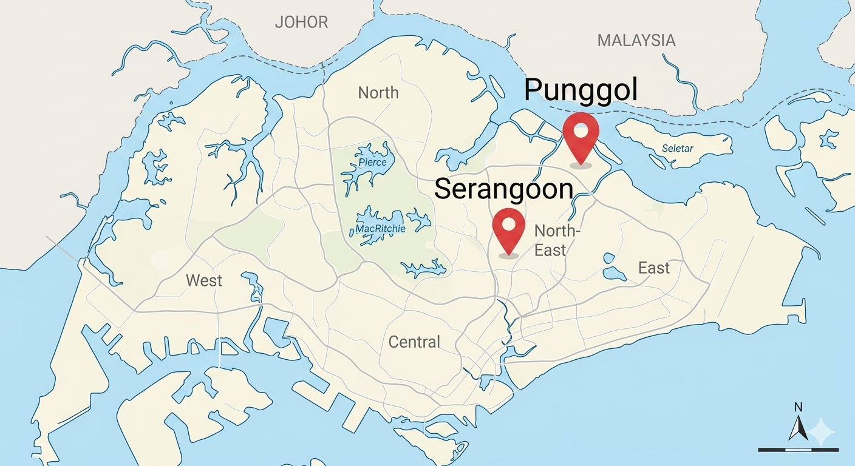

Resource 2 for Question 1
Site A – Outside Punggol Waterway Point
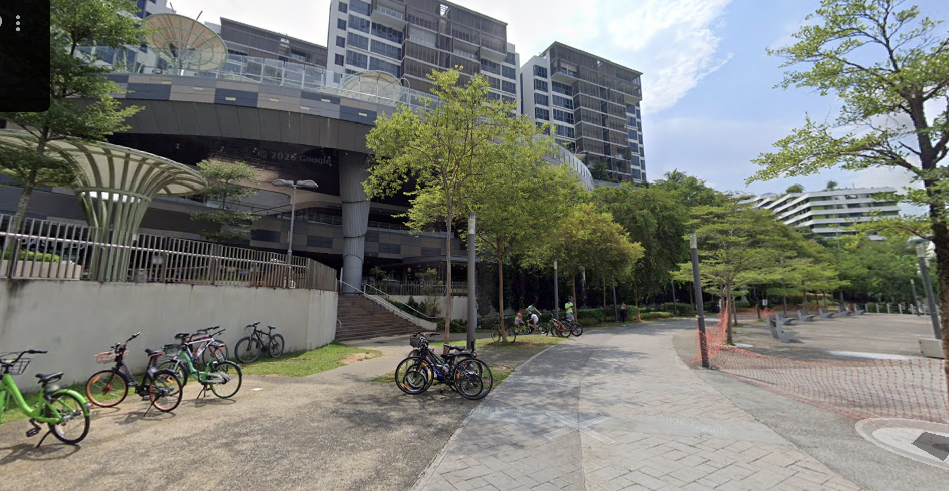

Site B- Outside Serangoon Nex
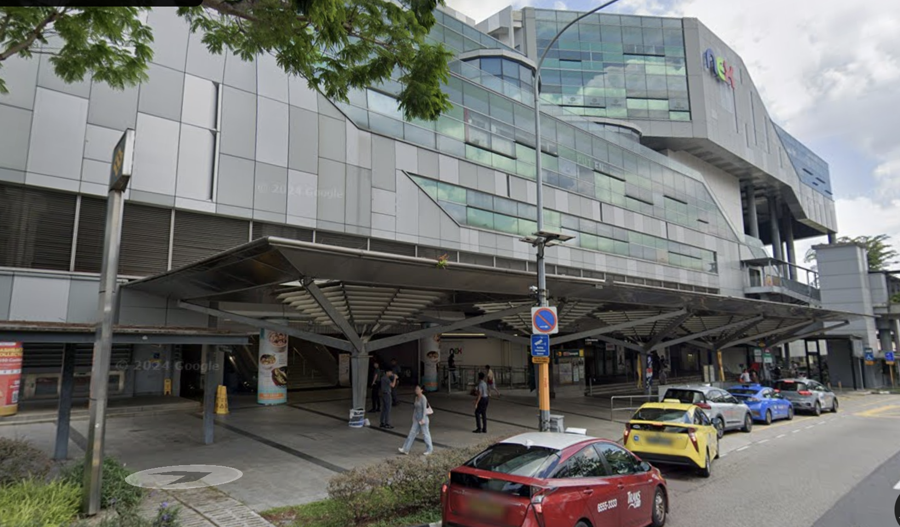

Resource 3 for Question 1
Questionnaire survey administered by the students
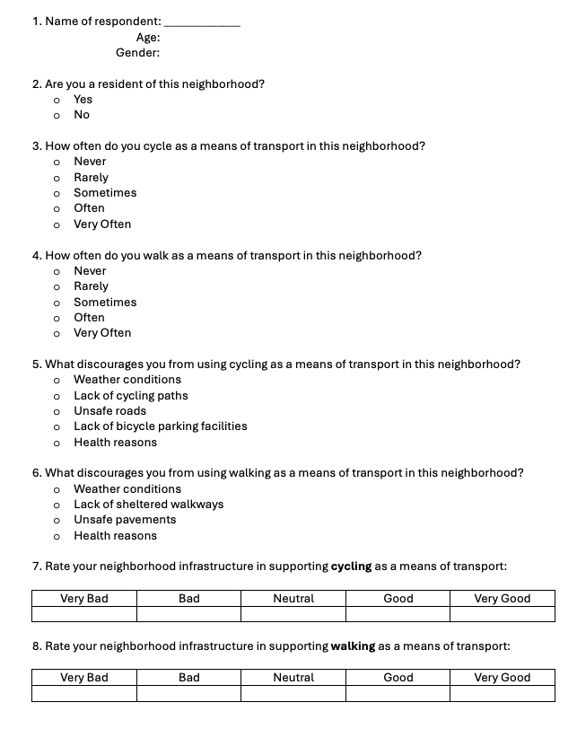

Resource 4 for Question 1
Some of the results collected by students at both sites
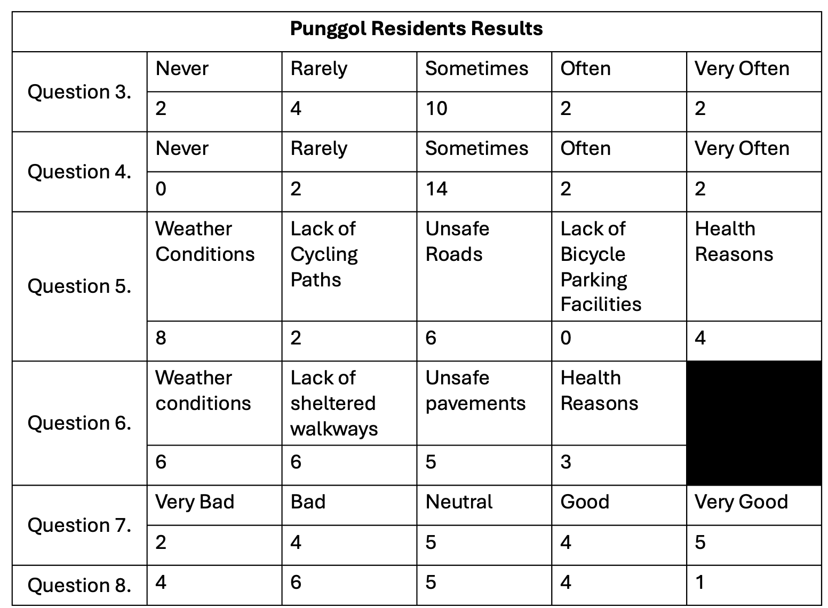

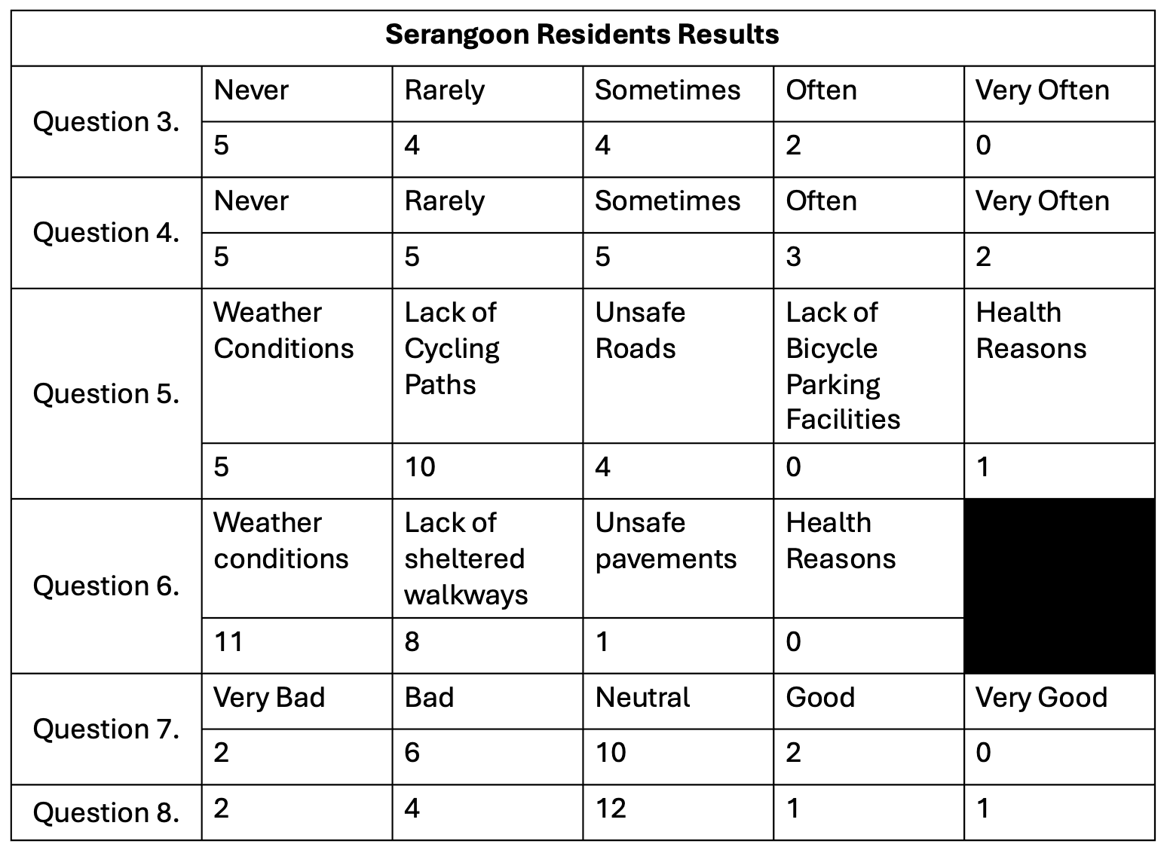
Resource 5 for Question 2
Carbon dioxide emissions per capita of selected countries
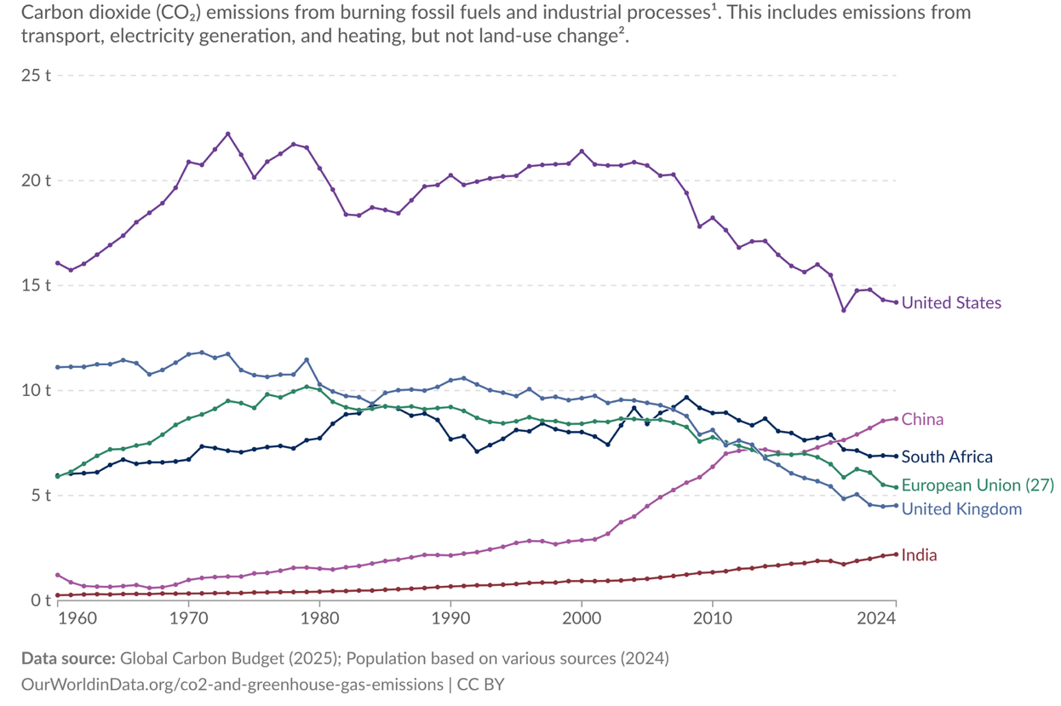
Resource 6 for Question 2
Cartoon portraying the impact of climate change
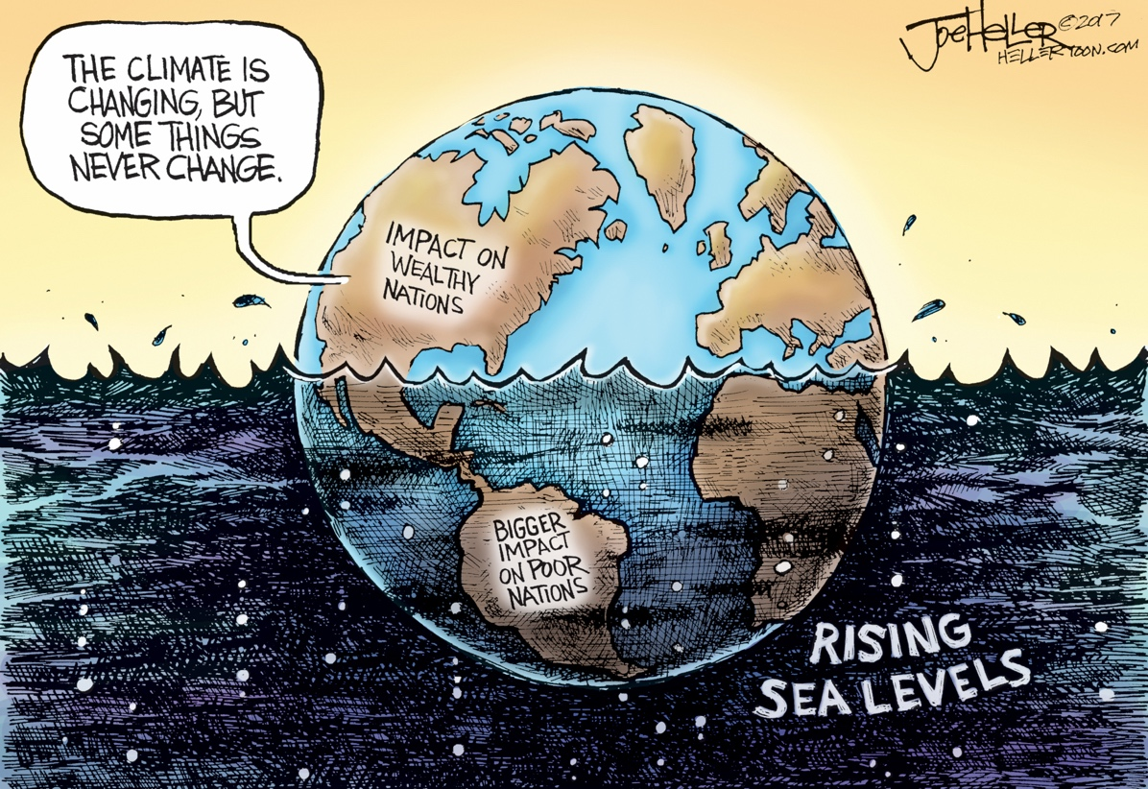
Resource 7 for Question 2
Urban slum in Manila, Philippines
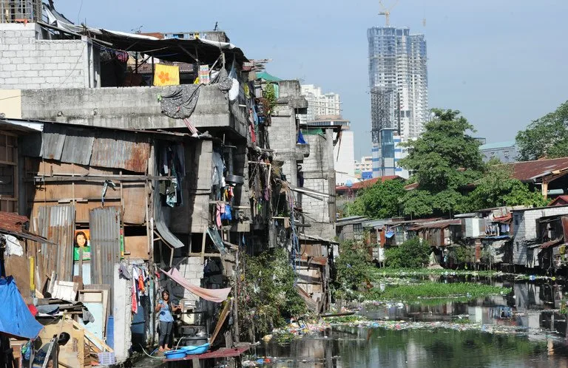

Blank Page

